2) Invariant mass plot for individual resonances: Sample code uploaded as Q2-sample, parameters are adjusted according to each particle

1. η meson (m = 547.86 MeV)

Fit performed on data range 0.53-0.63 GeV

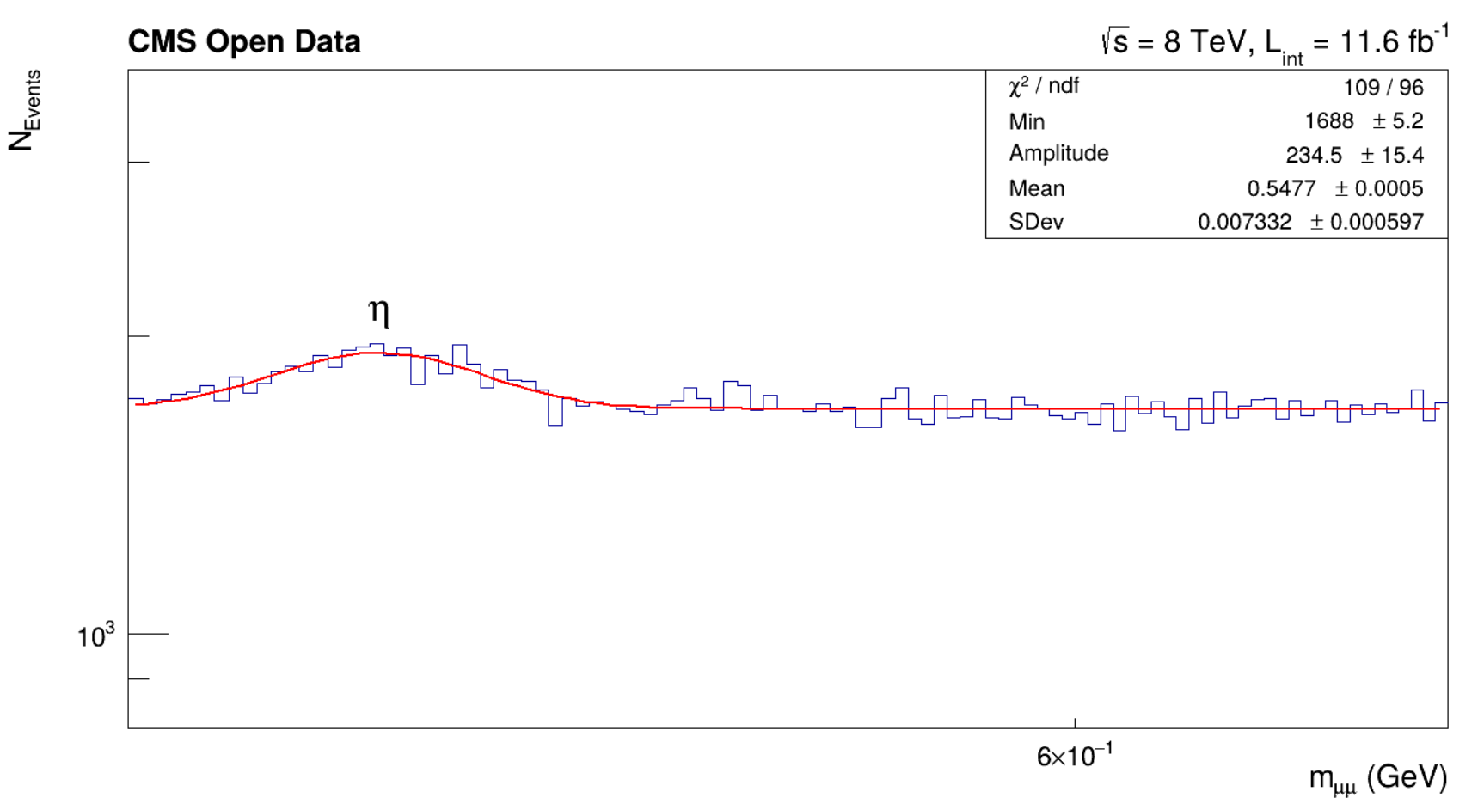

1. ⍴, ω mesons (m~775-782 MeV)

Data range analysed: 0.7-0.85 GeV

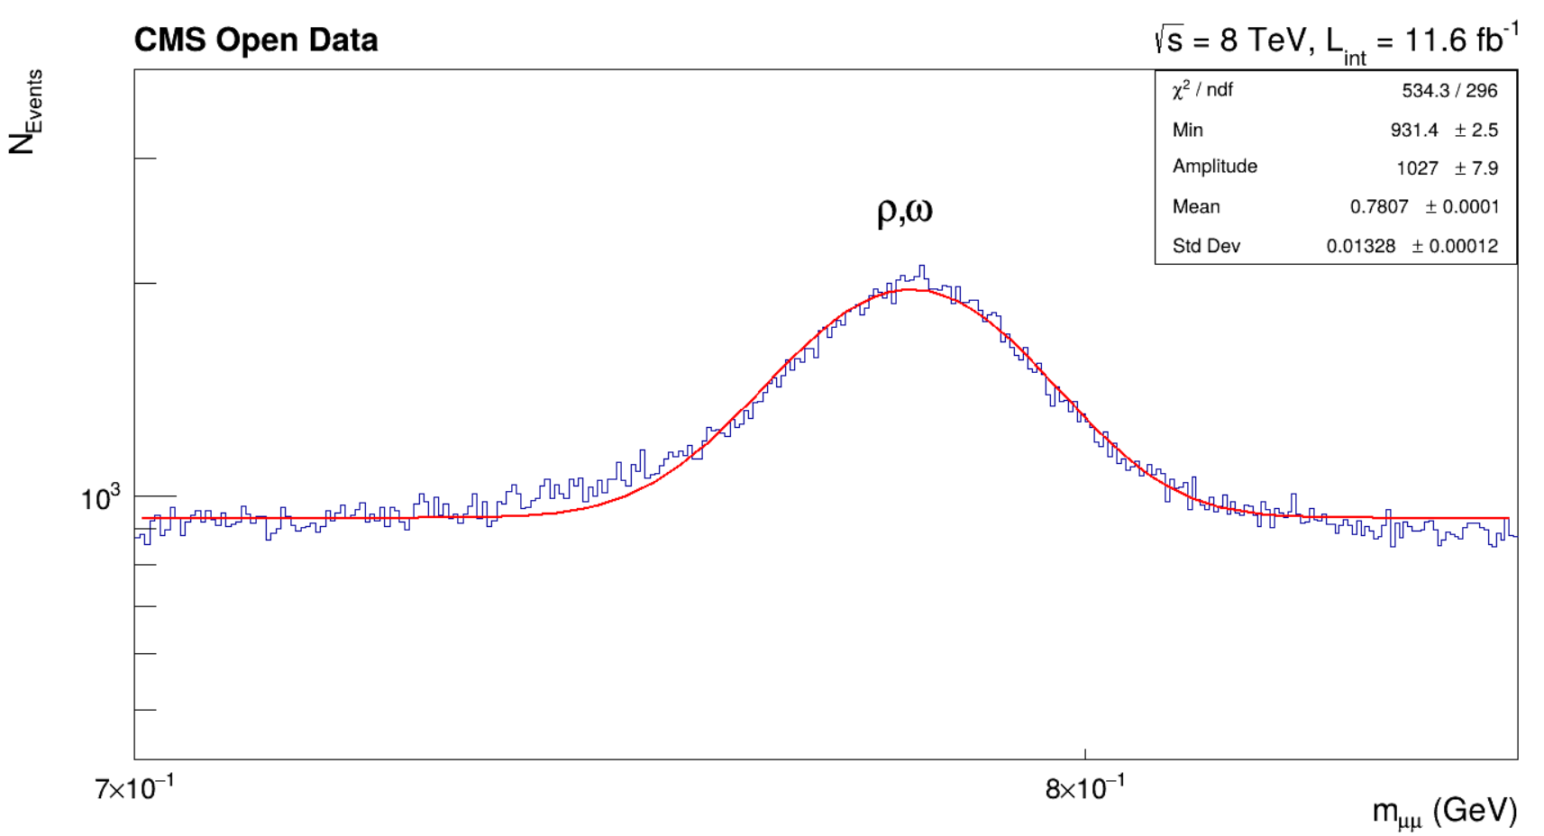

1. ɸ meson (m=1.019 GeV): Data Range- 0.95-1.1 GeV

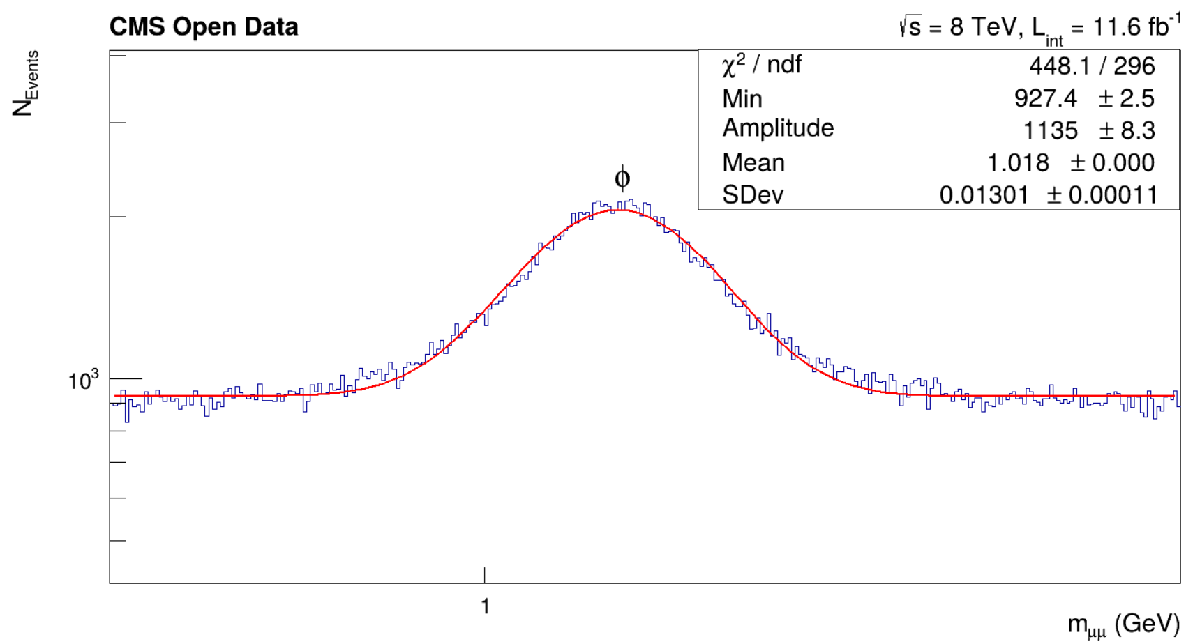

1. J/Ѱ meson (m=3.096 GeV) Data Range: 2.8-3.3 GeV

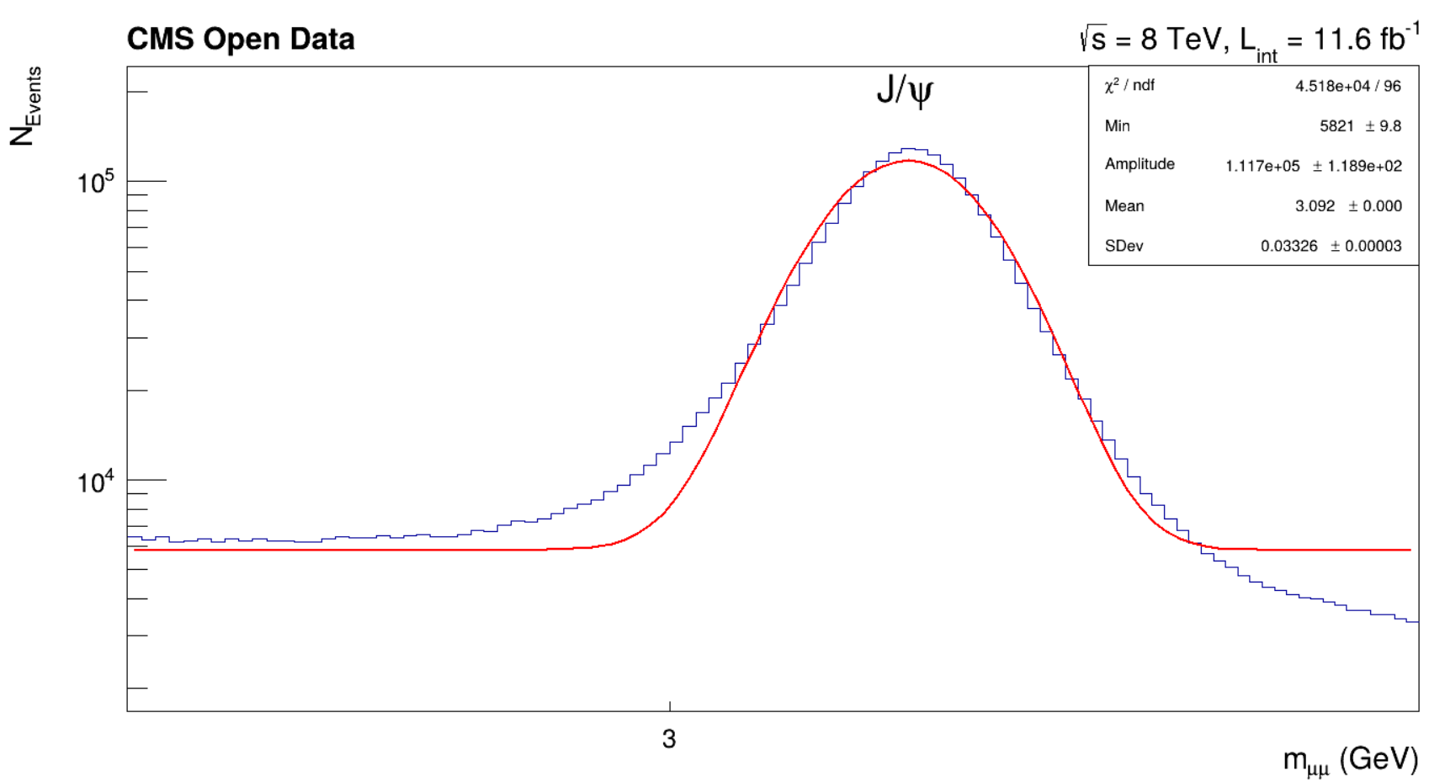

1. Ѱ’ (1st excited state of J/Ѱ) (m=3.686GeV) Data Range: 3.5-3.9 GeV

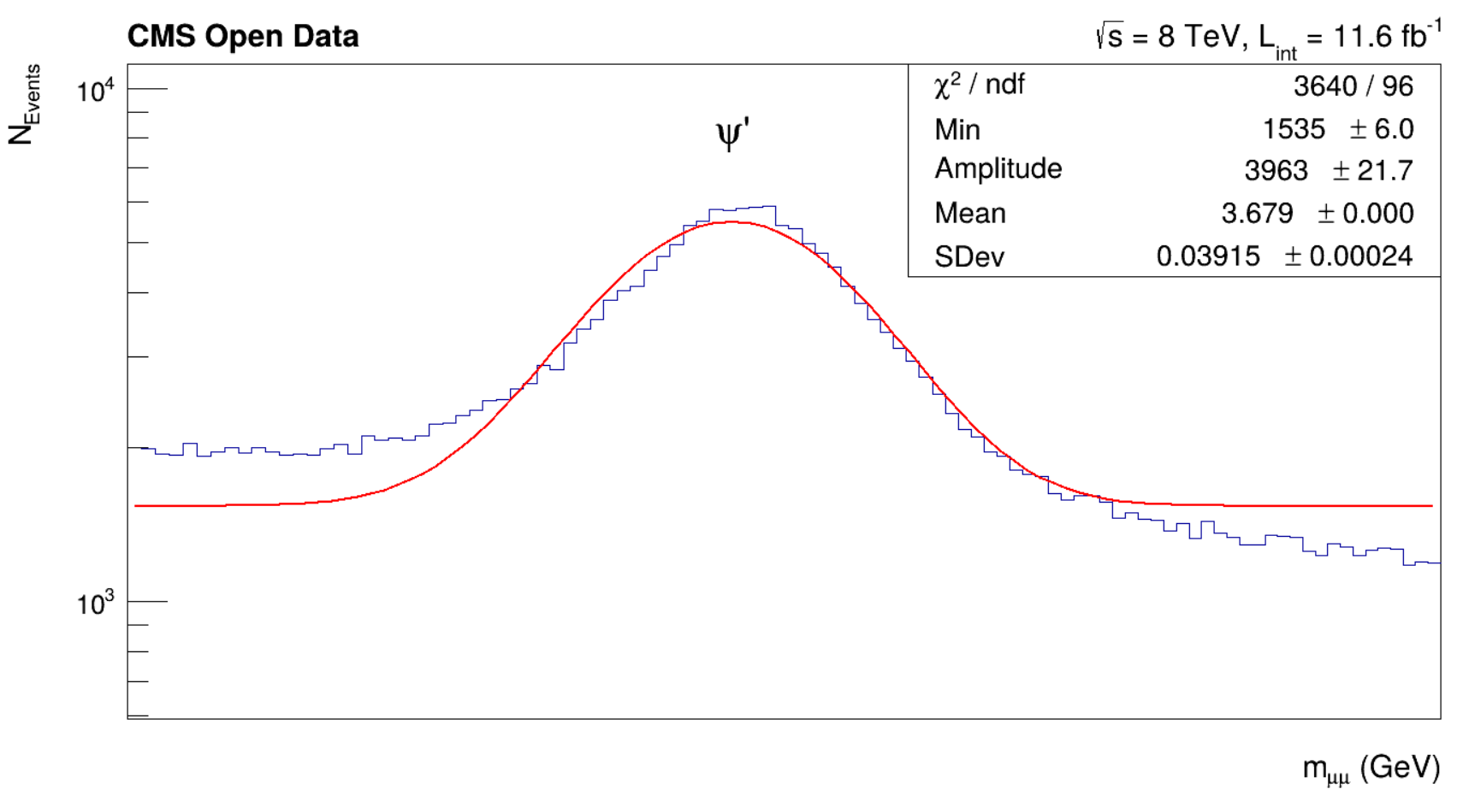

1. ϒ(1S, 2S, 3S) mesons (m=9.46, 10.023, 10.355 GeV) Data Range: 9-9.8, 9.8-10.2, 10.2-10.6

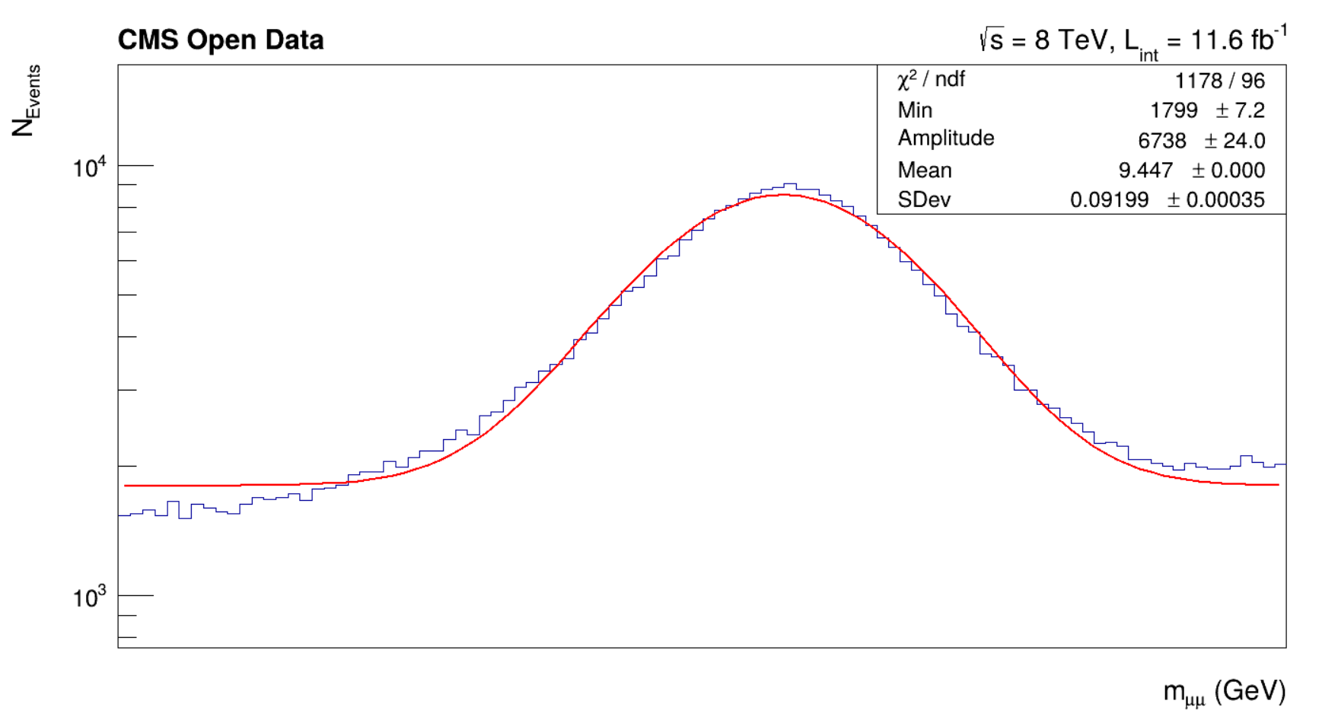

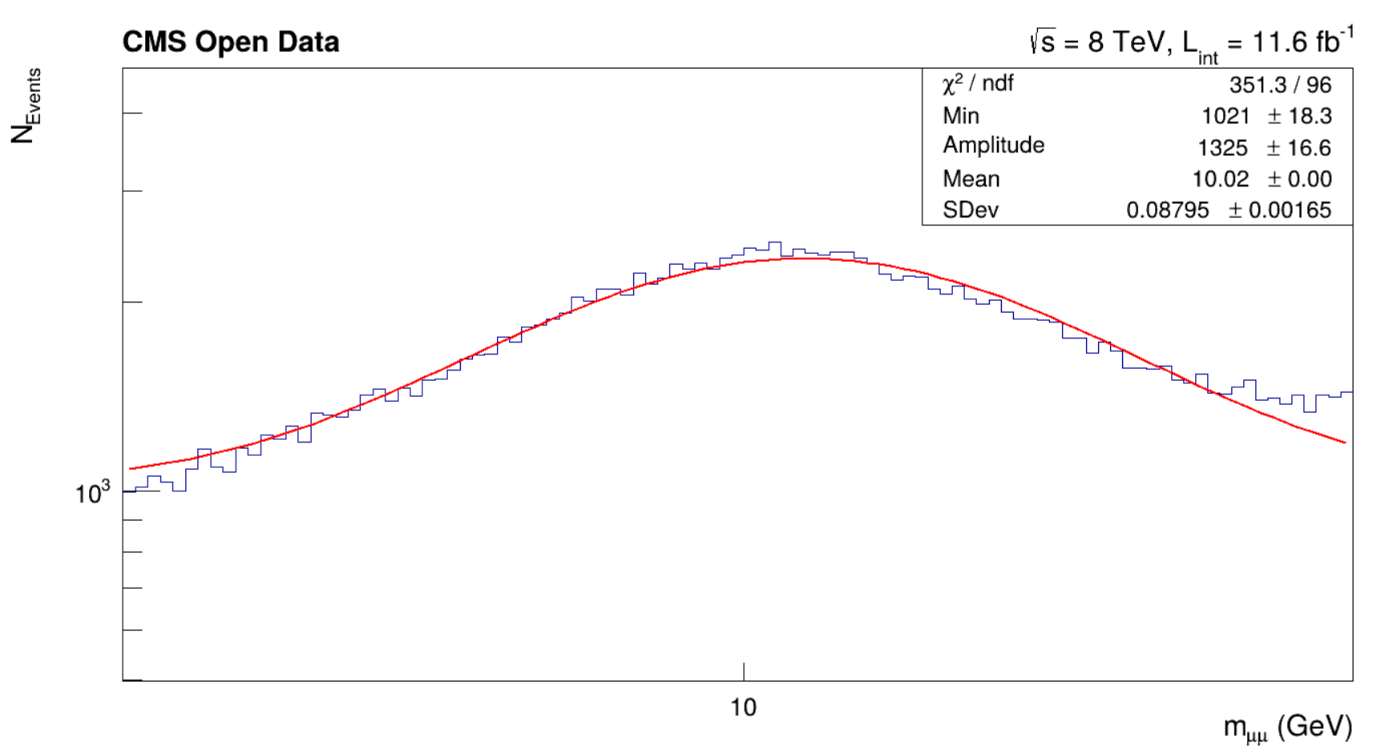

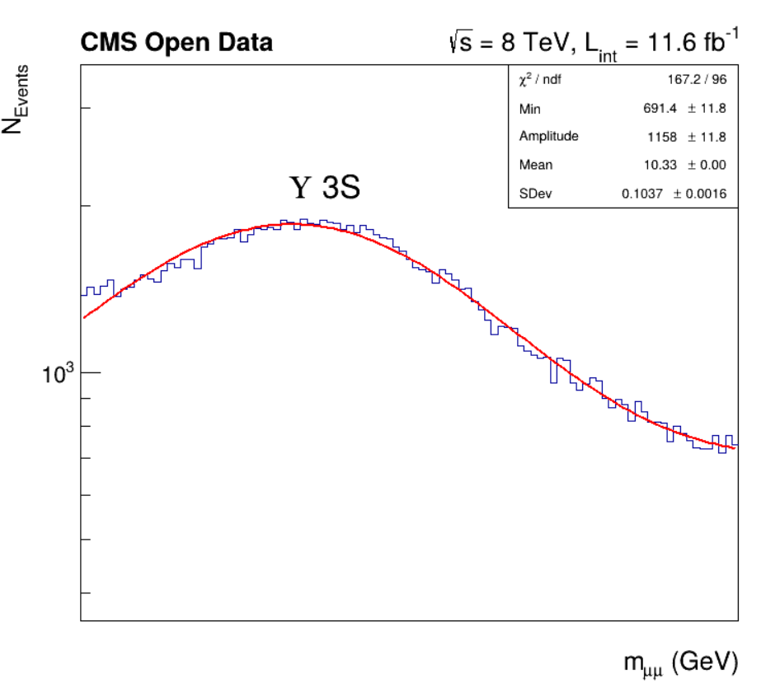

1. Z boson (m=91.1876 GeV) Data Range: 75-105 GeV

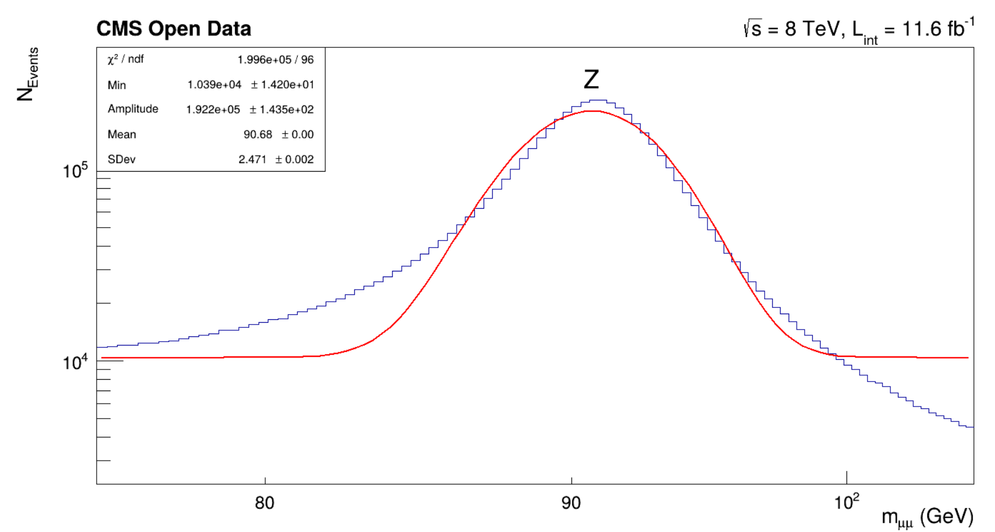

3) (pT, eta, phi)

1. X->mu+mu- : Sample code uploaded as Q3a_sample.C, parameters are varied for each particle using data ranges mentioned above
   1. η meson

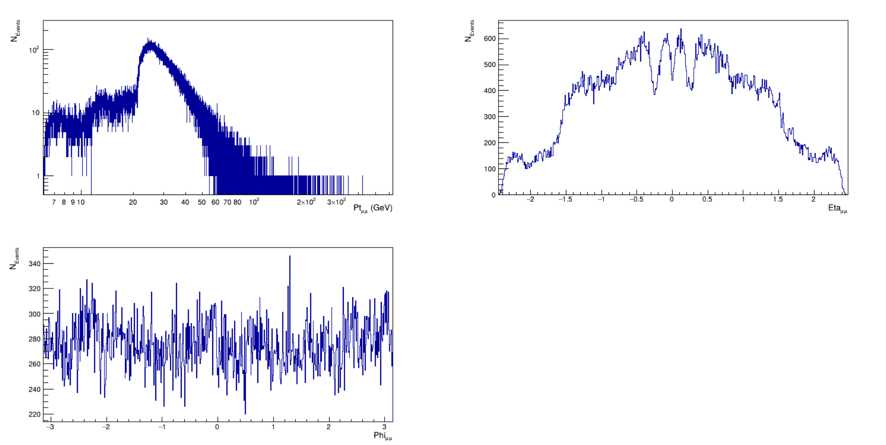

* 1. ⍴, ω mesons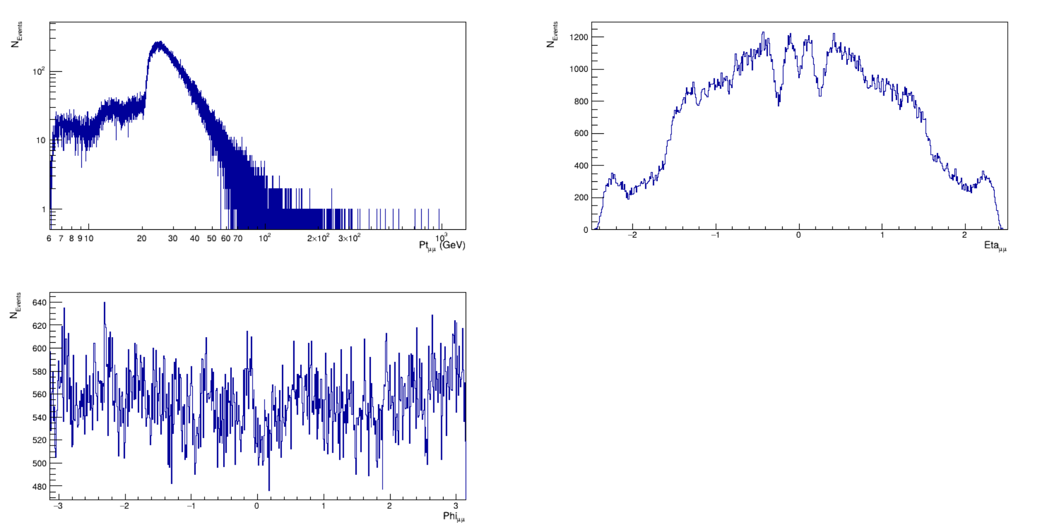
  2. ɸ meson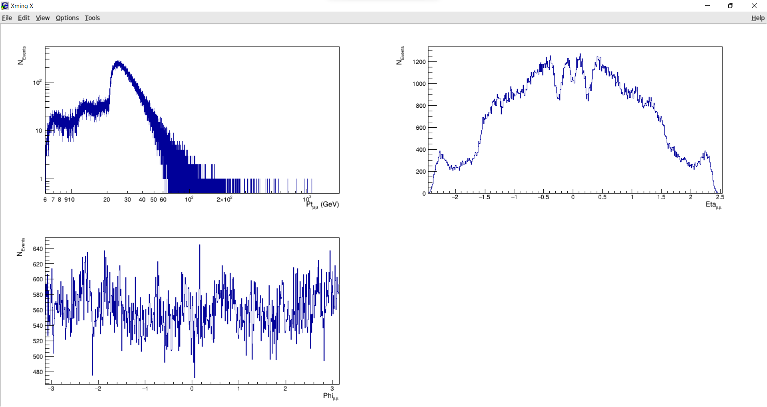
  3. J/Ѱ meson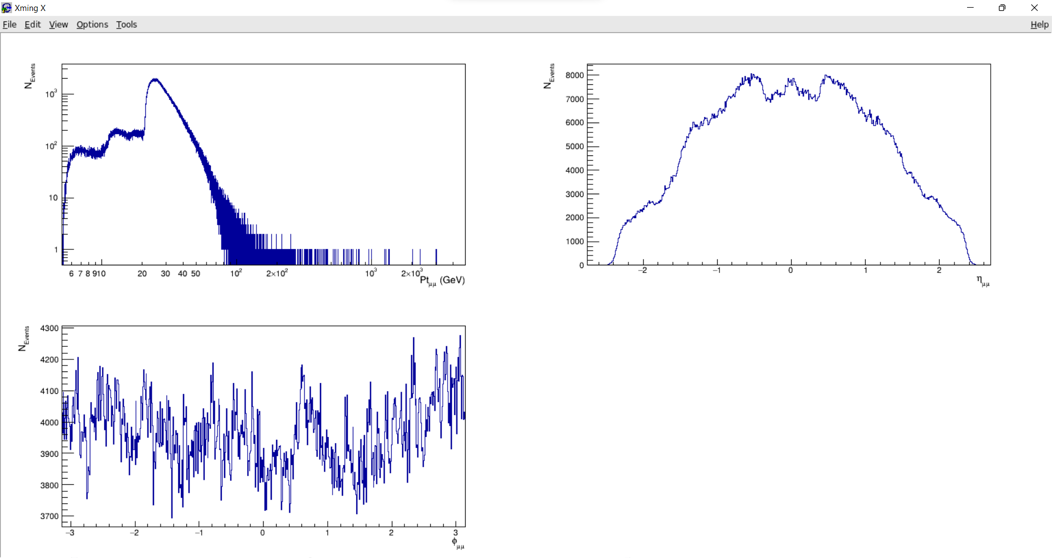
  4. Ѱ’ (1st excited state of J/Ѱ)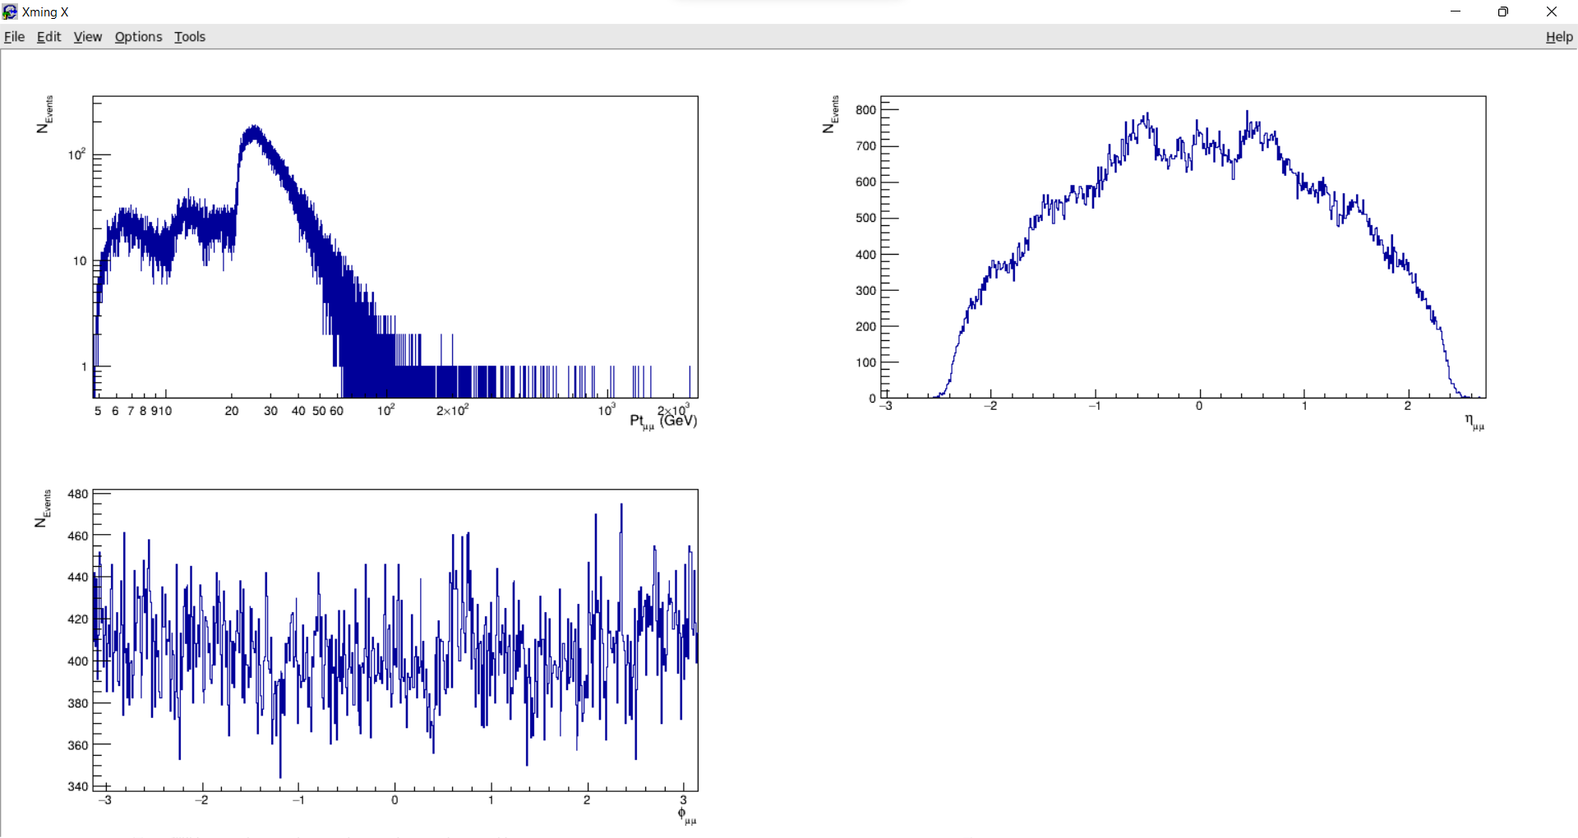
  5. ϒ(1S, 2S, 3S) mesons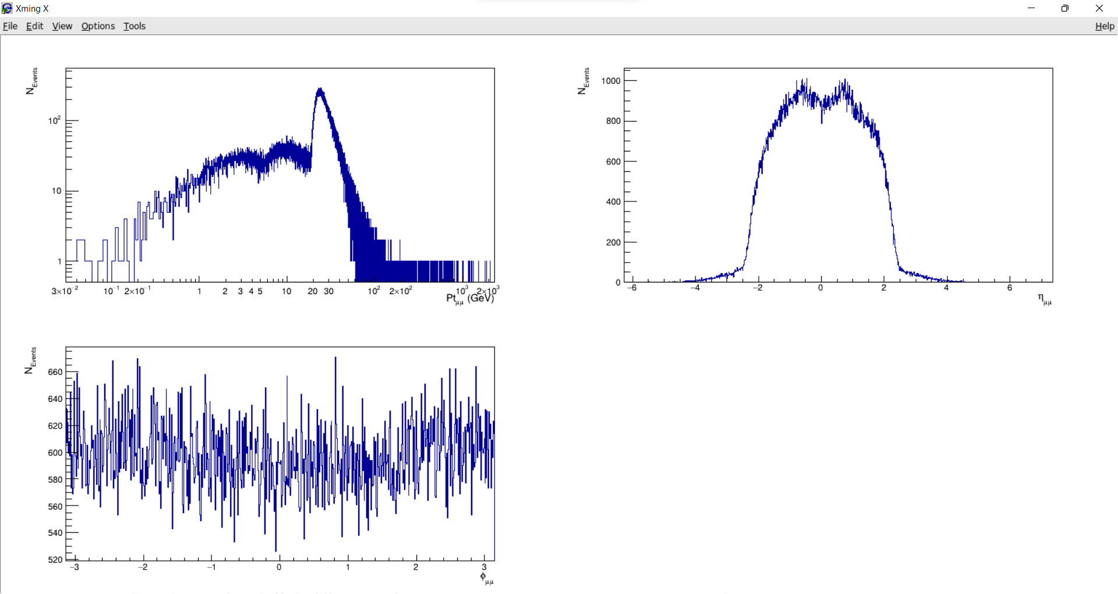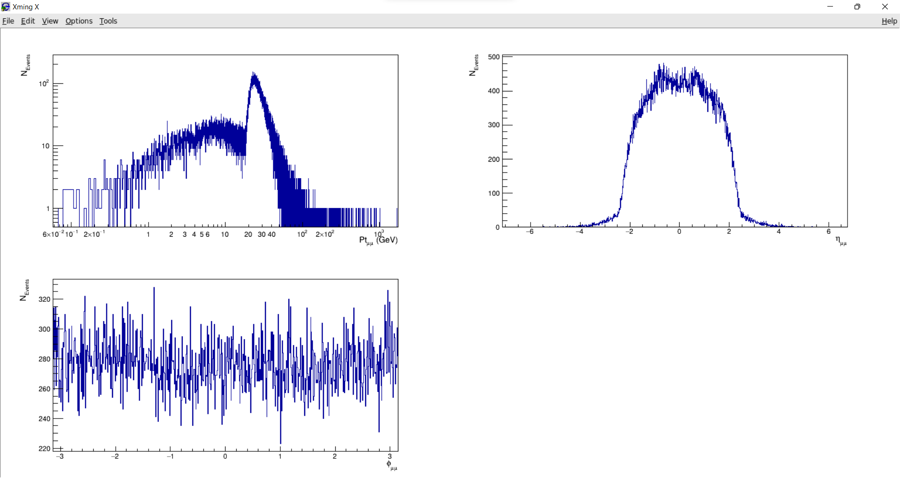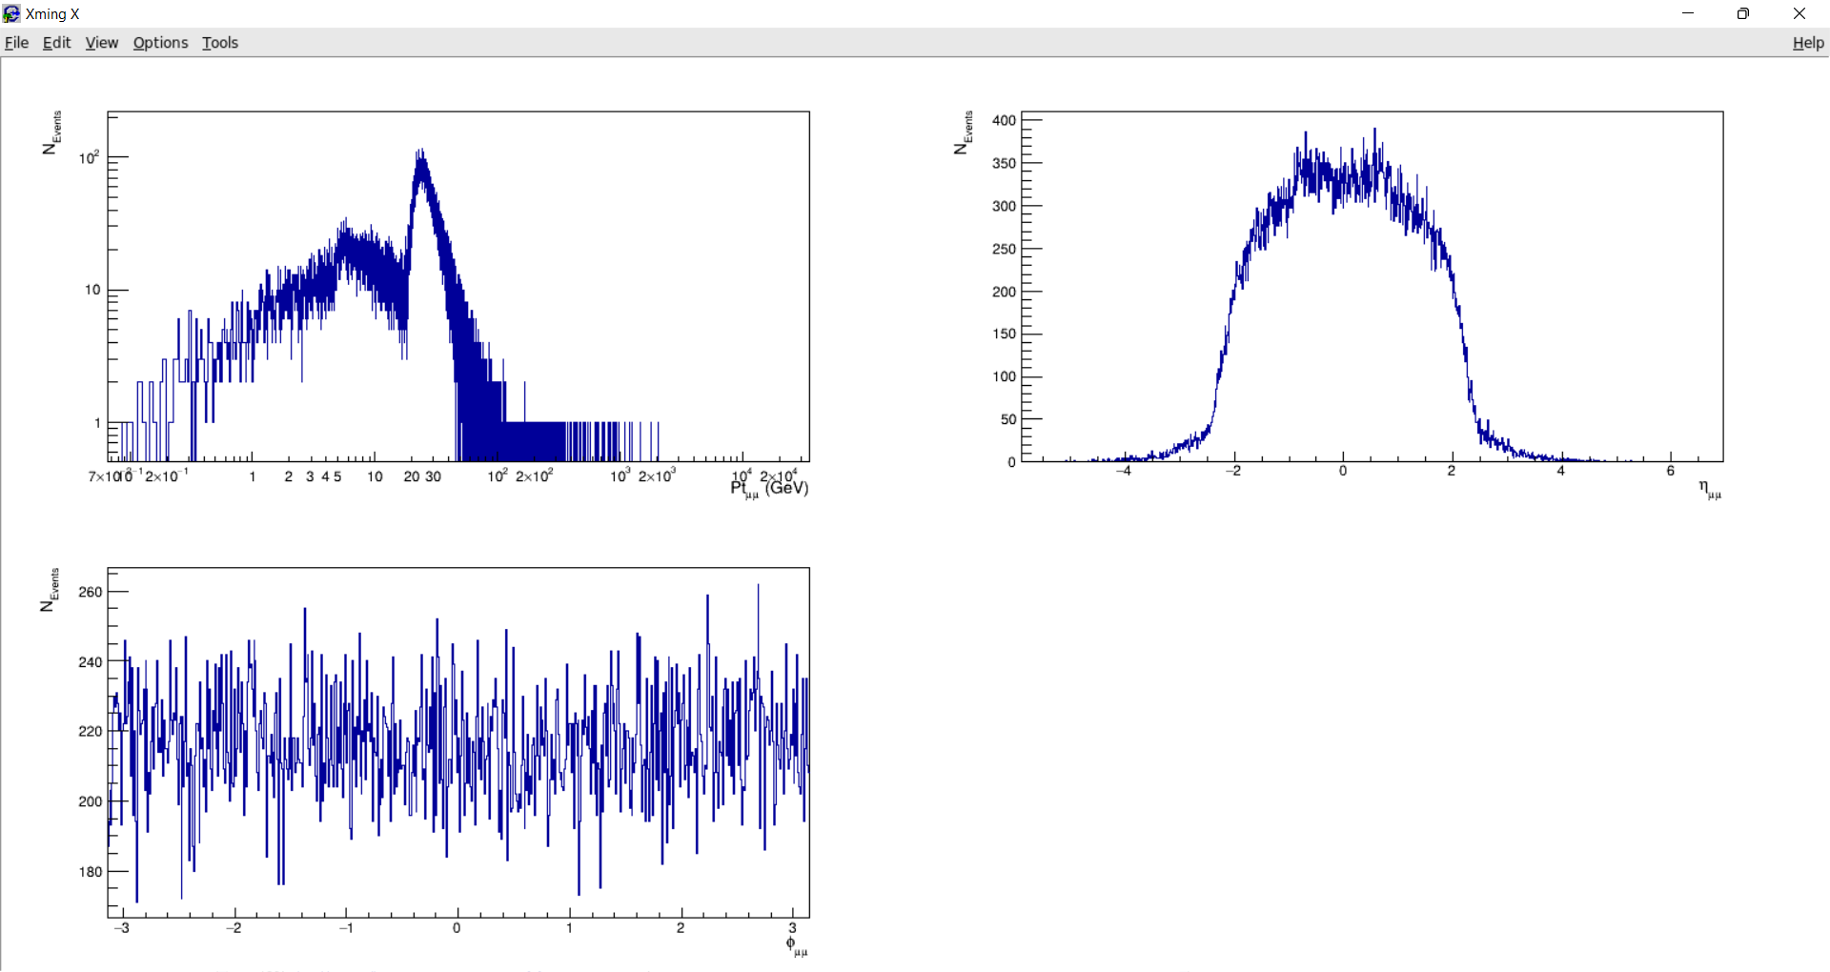
  6. Z boson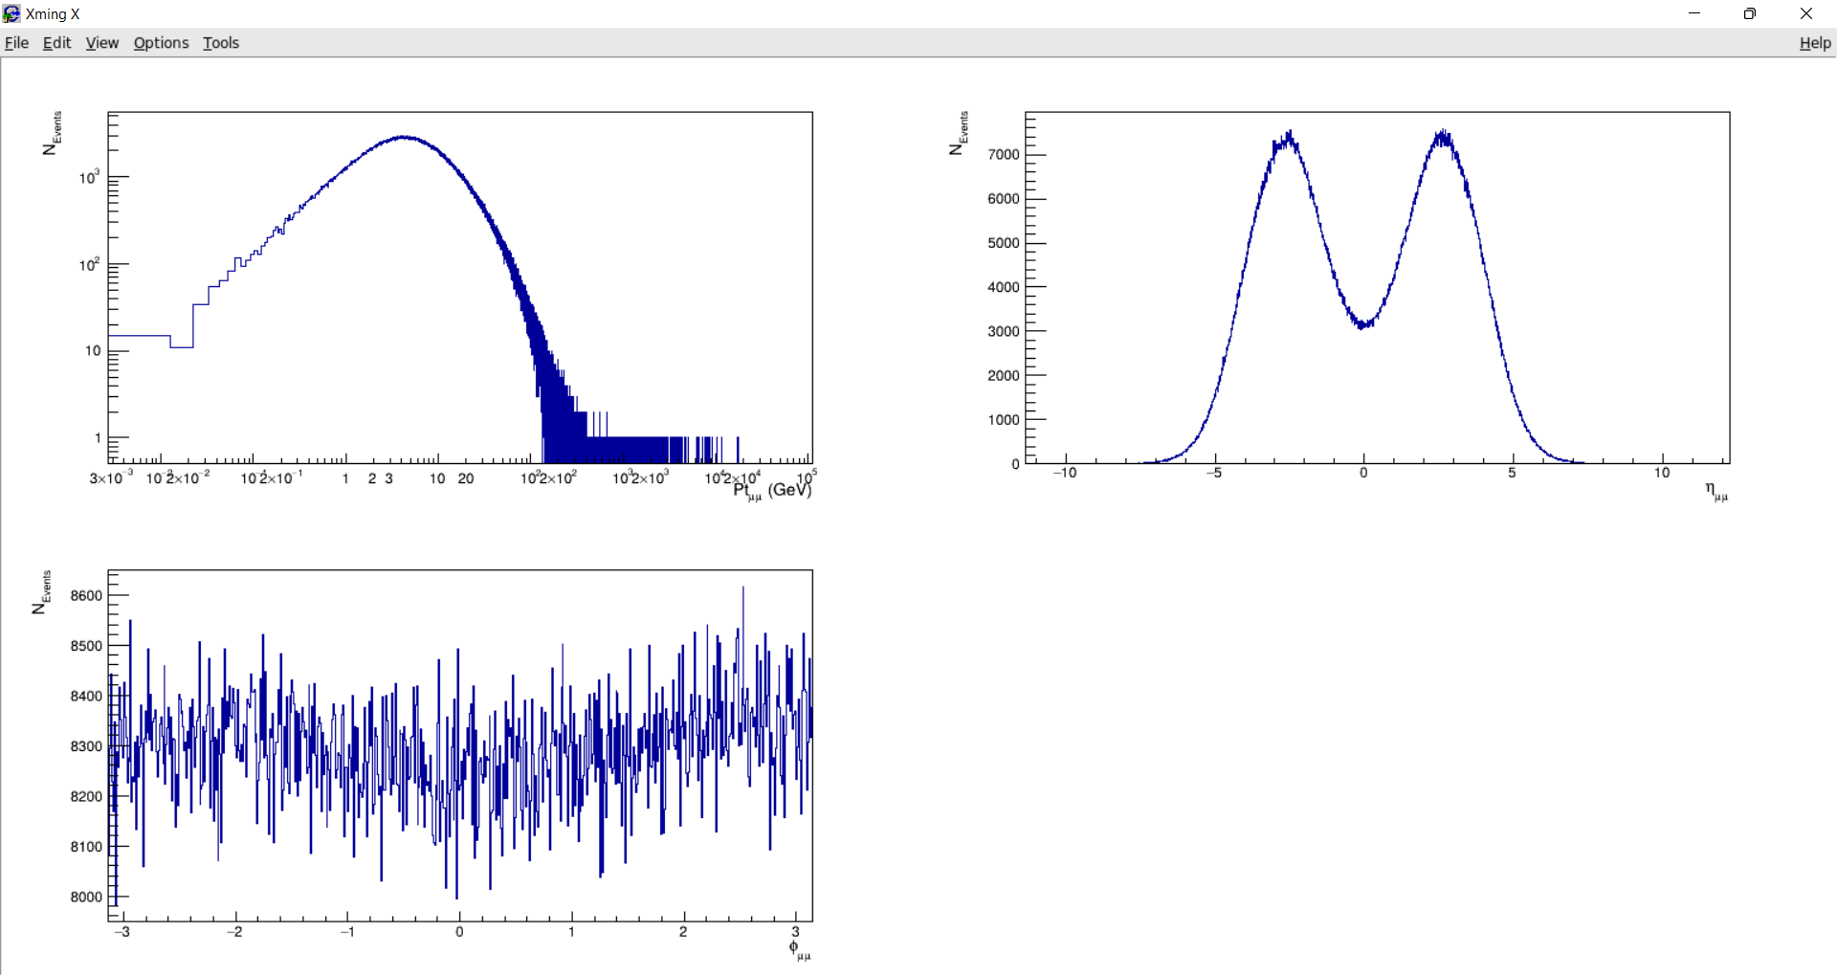

1. mu+ & mu- graphs: Sample code is uploaded as Q3b_sample.C. Invariant mass used to apply cuts is taken from ranges mentioned above (Q2). Top 3 graphs correspond to mu+
   1. η meson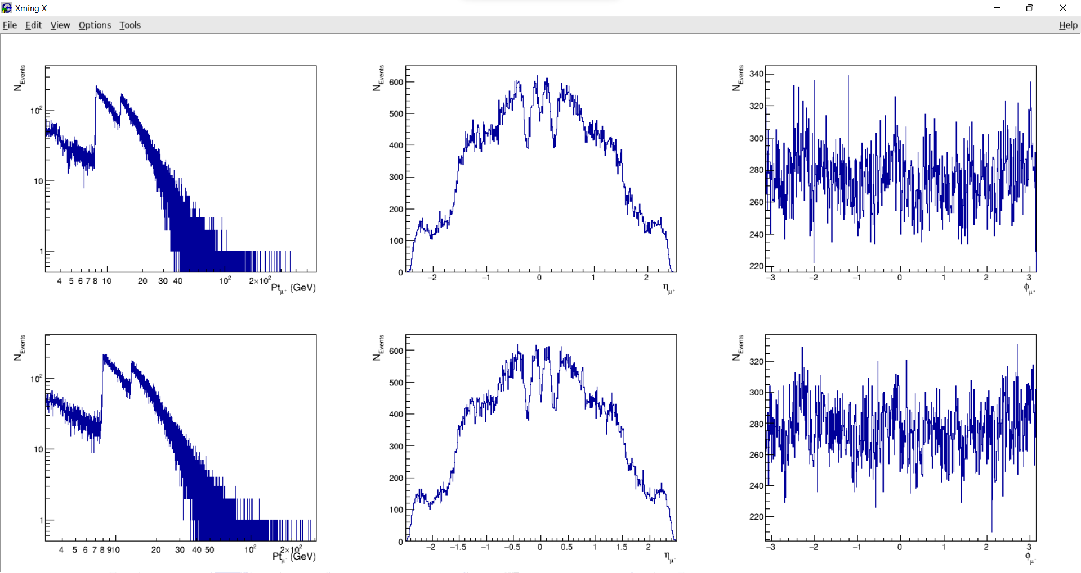
   2. ⍴, ω mesons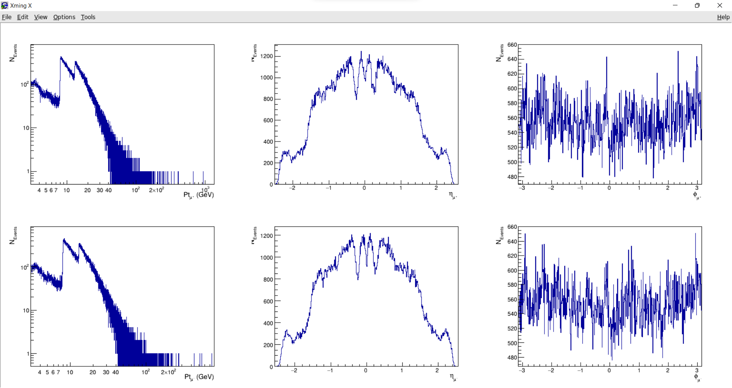
   3. ɸ meson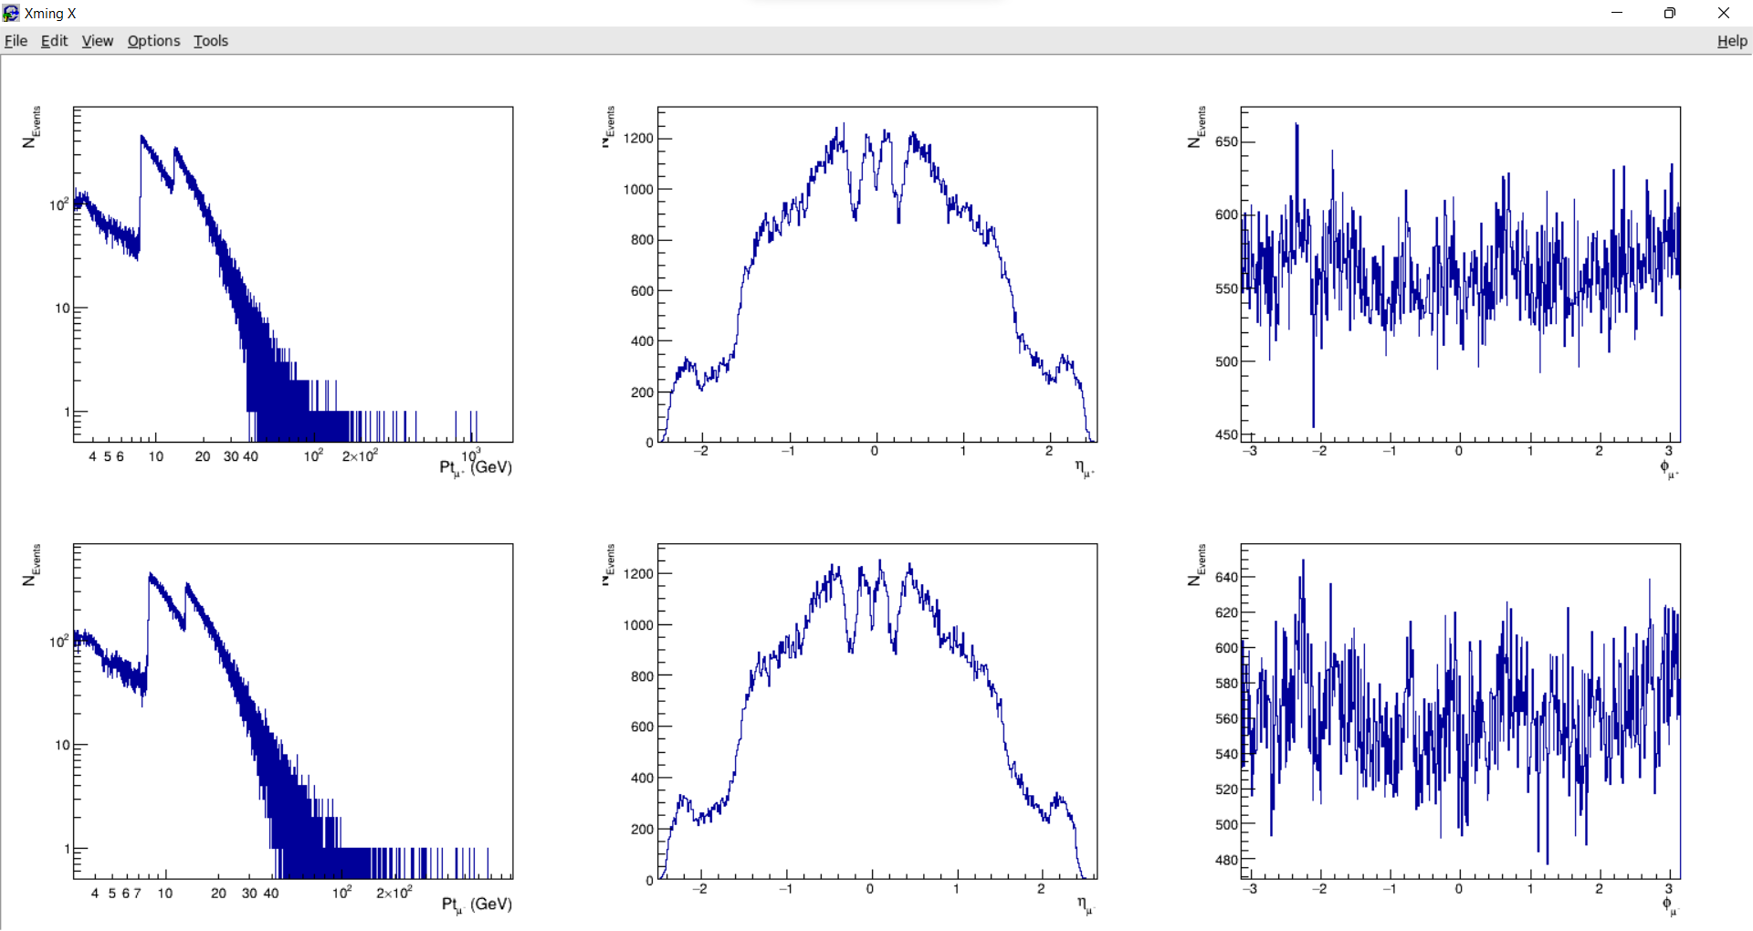
   4. J/Ѱ meson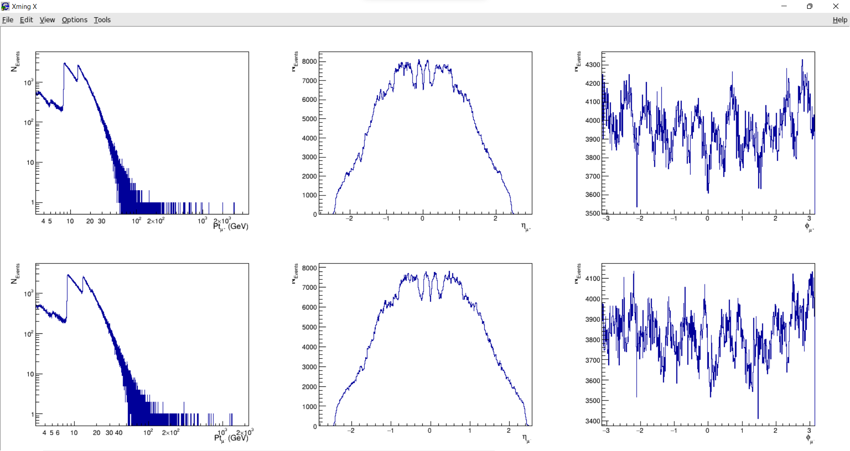
   5. Ѱ’ (1st excited state of J/Ѱ)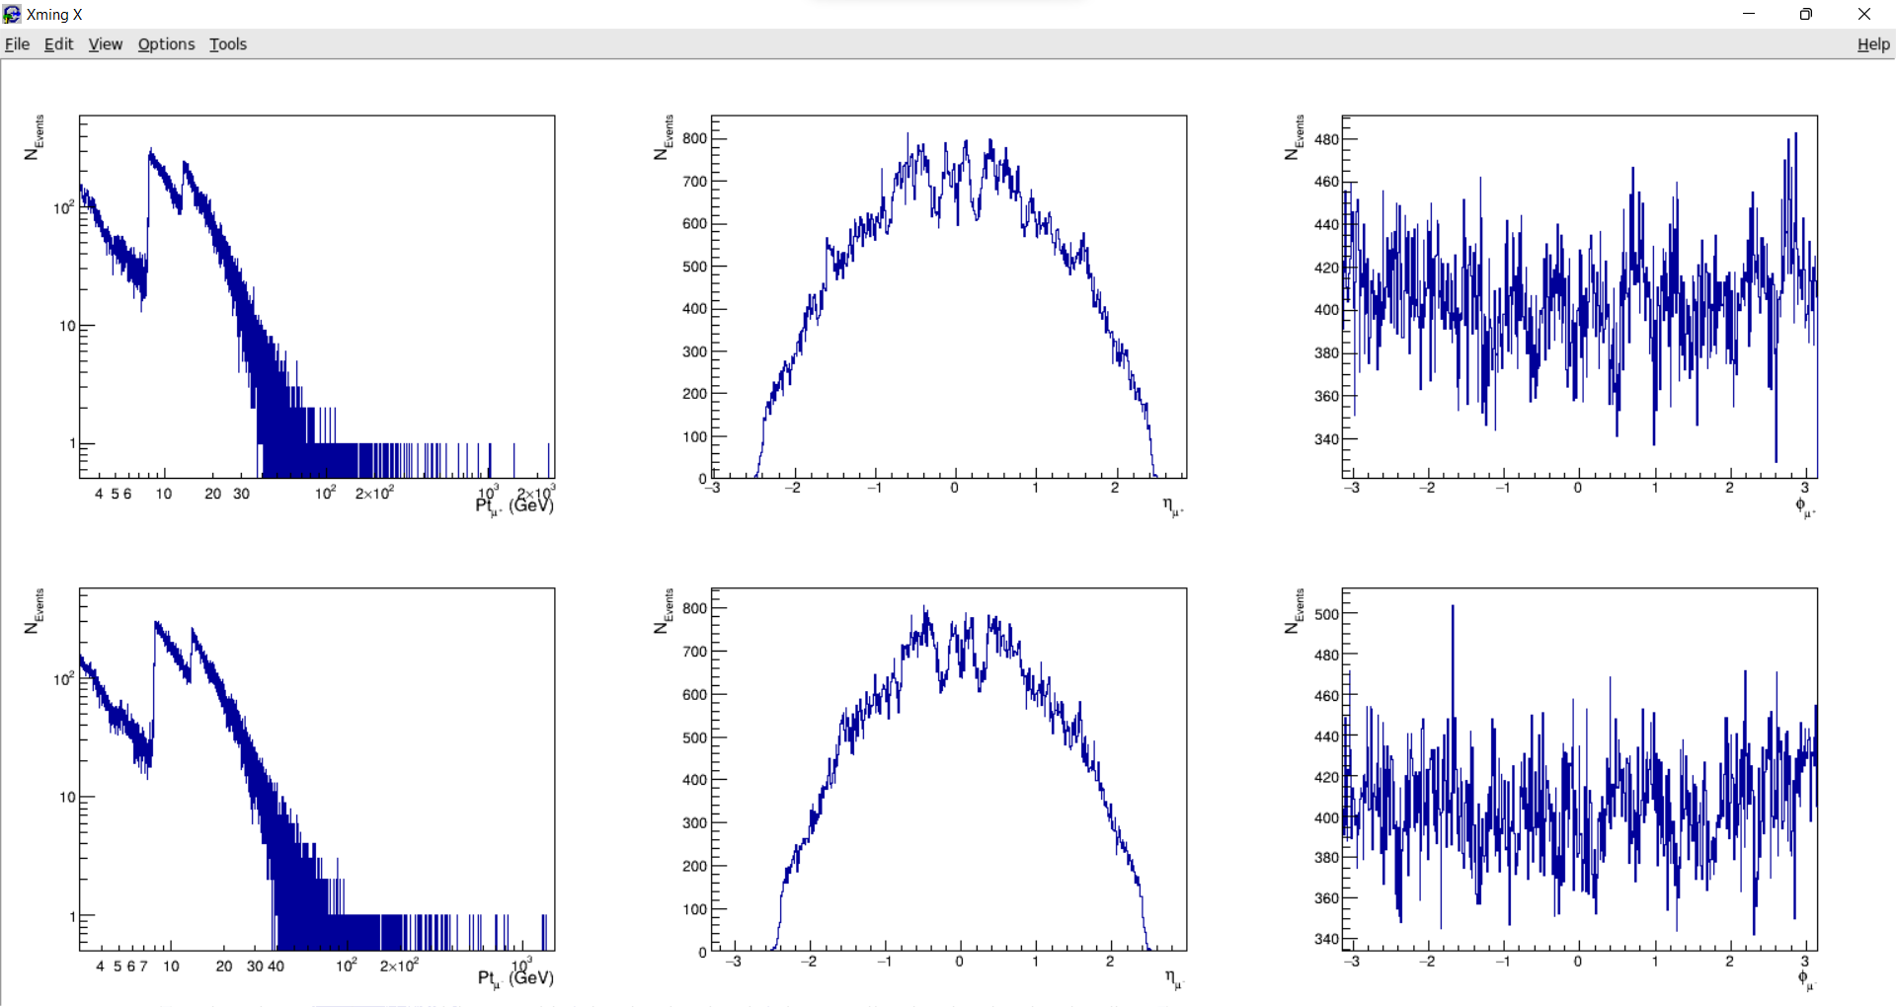
   6. ϒ(1S, 2S, 3S) mesons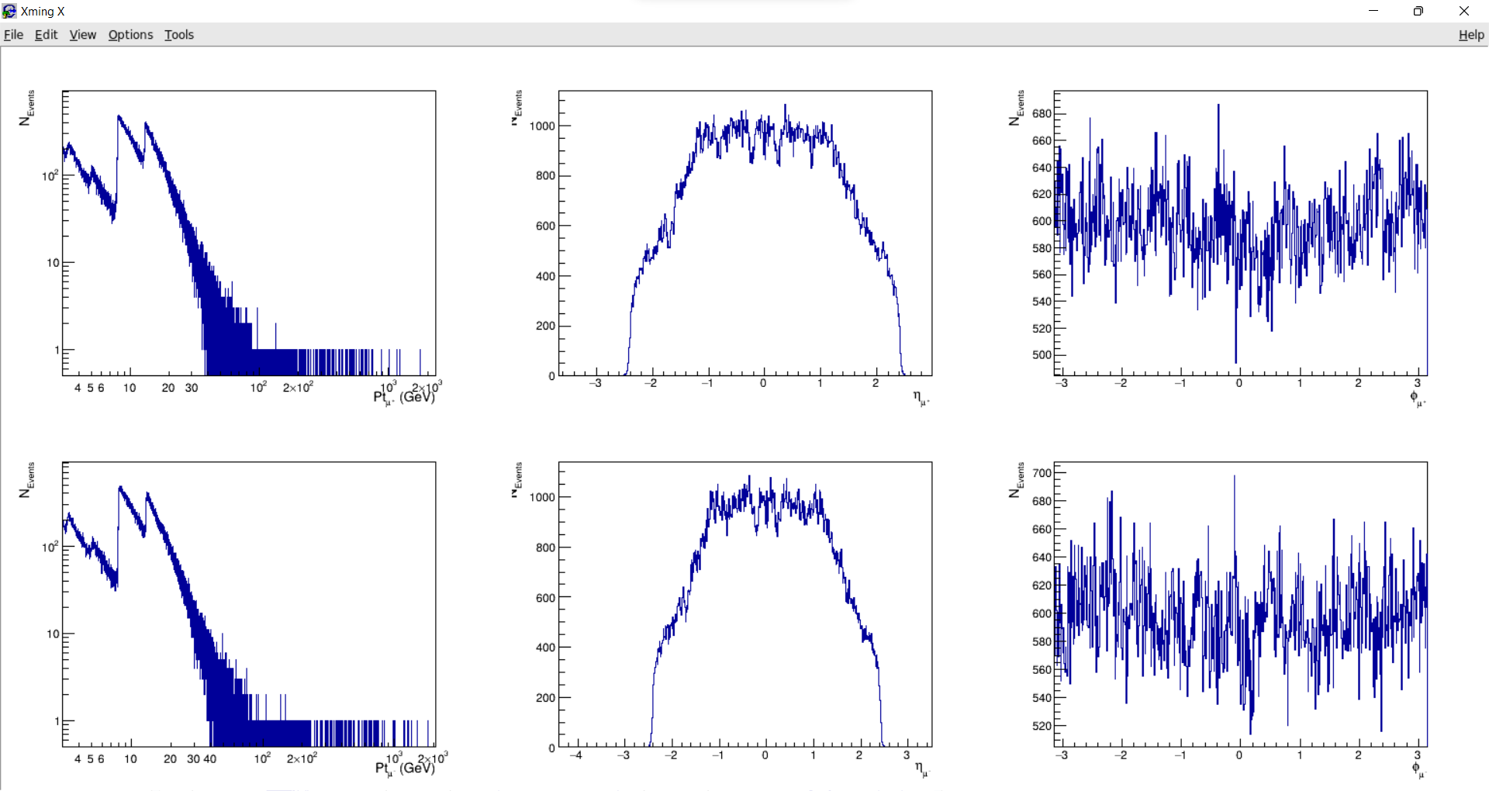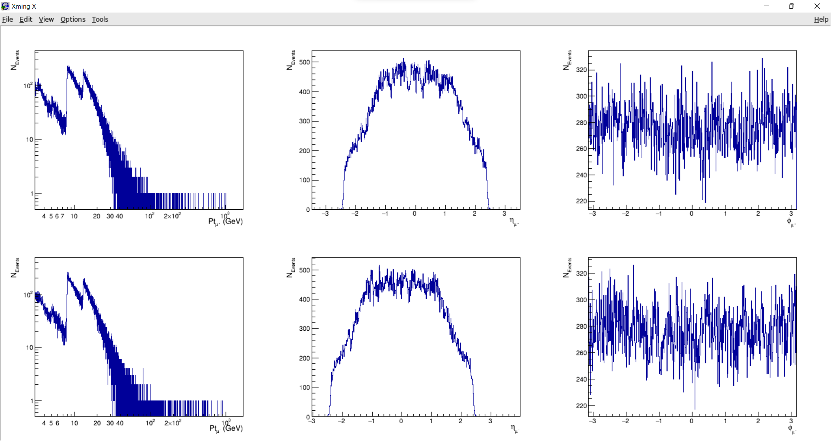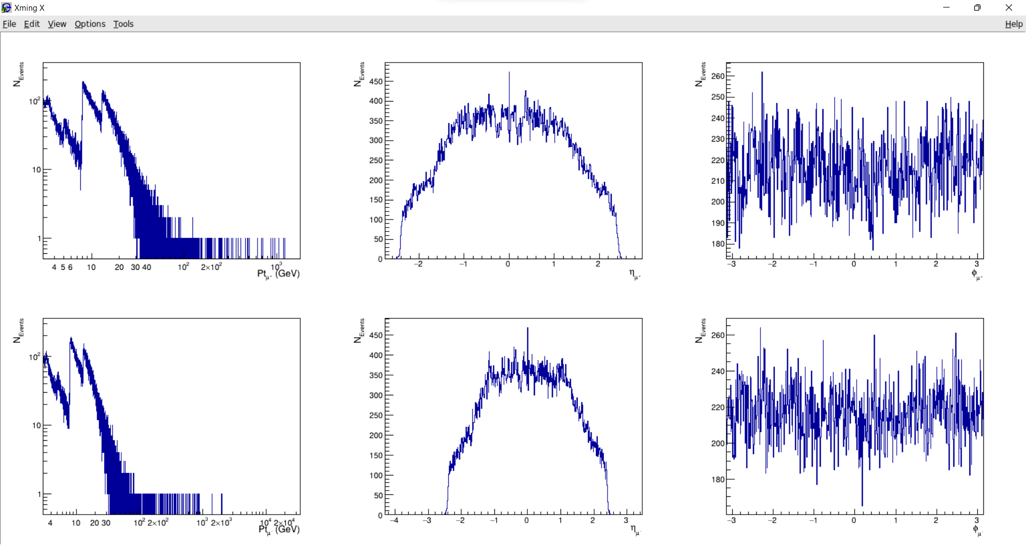
   7. Z boson